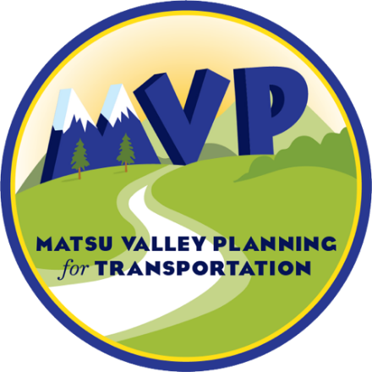

MatSu Valley Planning for Transportation


Public Participation Plan
Approved DATE
Contents
What is a Public Participation Plan? 1
What is MVP and why was it formed? 2
History of MPOs 2
Formation of MVP 2
Community Partnerships 5
Federal Coordination 5
State Collaboration 5
Local Connection 5
What does MVP do? 7
Why is public participation required? 11
How does MVP ensure transparency? 13
Equity and Nondiscrimination 13
Removing Barriers to Participation 13
Requests for Special Accommodations and Complaints Procedure 14
Monthly Open Meetings 14
Ongoing Online Access 15
How can people participate? 16
Everyday Engagement Tools 16
Visual Identity and Recognition 16
Digital Presence 16
Traditional Media 16
Information Design 17
Community Connection 17
In-Person Access and Support 17
Open Meeting Framework 17
Comprehensive Engagement Tools 18
Public Review and Comments 18
Detailed Communication Plans 19
Expanded Digital Presence 19
Broader Media Strategy 20
Targeted Feedback Collection 20
Direct Community Outreach 20
Enhanced Accessibility 20
Specialized Engagement 21
How does MVP measure success? 22
Conclusion 23
Abbreviations and Definitions 24

Table of Tables
Table 1. Public Outreach Snapshot for MVP’s Plans and Programs 8
Table 2. Requirements for Administrative Modifications and Amendments 10
Table 3. Meeting Notice Protocol 17
Table 4. Plan Review Period Notice Protocol 18
Table 5. Example Measures by Type of Activity 21

What is a Public Participation Plan?
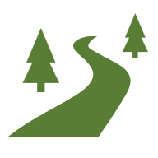
This Public Participation Plan (PPP) is the foundation for a continuous, cooperative, and comprehensive (3Cs) transportation planning process in the MatSu Valley Planning for Transportation (MVP) planning area. It provides context for the history and purpose of MVP, explains the federal requirements that guide the planning and public participation processes, and identifies strategies to encourage community members to share their ideas and feedback on transportation issues, plans, programs, and projects. The PPP also outlines how MVP will measure the success of public outreach.
MVP’s goal is to create a well-connected, multimodal transportation system that supports the efficient and fair movement of people and goods. A multimodal system means having options—walking, biking, taking transit, or driving.
The purpose of MVP’s PPP is to provide:
- The public with a guidebook for how to participate in the regional transportation planning process.
- MVP with a set of policies and procedures for public engagement that enhance the transportation planning process, meet state and federal requirements, and assist in achieving the following goals:
- Equity: Commit to a just, fair, inclusive, accessible, and authentic public process that encourages a diversity of participants in the transportation planning process by engaging with transportation-disadvantaged communities.
- Transparency: Provide and encourage participation in the transportation planning process through a transparent PPP and other well-defined and accessible resources.
- Inform: Provide increased awareness of the functions of the MPO and the overall planning process to enhance the quality of public participation and feedback.
- Implementation: Develop transportation plans and projects that incorporate feedback from the community and document the community’s impact on decision-making.
- Improvement: Evaluate the effectiveness of public engagement efforts through qualitative and quantitative metrics and use that information to enhance MVP’s public engagement practices.

What is MVP and why was it formed?
MVP is the Metropolitan Planning Organization (MPO) for the urbanized area of the Matanuska-Susitna Borough (MSB). An urbanized area (UZA) is a region with a population of 50,000 or more—when a region’s population reaches this size, it is required to have an MPO.
The purpose of MVP is to serve as the regional transportation planning organization for the greater core area of Matanuska-Susitna (MatSu). MVP develops transportation plans and policies for the region, sets priorities for the use of federal transportation funds, and provides a forum for collaborative regional decision-making. These decisions are made by the Policy Board, which receives recommendations from the Technical Committee and support from MVP staff. The Policy Board and Technical Committee are discussed in more detail throughout this PPP.
This section explains the history of MPOs and why and how MVP was formed.

History of MPOs
MPOs were established in response to the rapid expansion of the interstate highway system in the 1950s, which often proceeded with little to no input from local communities. The Federal-Aid Highway Act of 1956 launched the largest public works program in United States history, funding the construction of 41,000 miles of interstate highways. However, the top-down approach—led by state departments of transportation—frequently disrupted cities and towns and displaced neighborhoods, particularly in low-income and minority communities. Mounting public opposition and lawsuits in the late 1950s and early 1960s highlighted the need for a more inclusive process. In response, the Federal-Aid Highway Act of 1962, signed by President John F. Kennedy, mandated that urban areas with populations over 50,000 implement a 3Cs transportation planning process between states and local governments. This requirement gave rise to today’s MPOs, which are tasked with ensuring that transportation planning reflects community input and promotes equitable outcomes.

Formation of MVP
The MSB is located north of the Municipality of Anchorage. As of the 2020 census, the MSB has a population of 107,081 living across 25,260 square miles and is experiencing rapid growth, with the population increasing by approximately 20 percent since the 2010 census. Along with this growth, the density of the core area (comprising the cities of Wasilla and Palmer and the region between them) has reached the threshold to be designated an urbanized area by the U.S. Census Bureau., Because of this growth and density, MVP was designated as the MPO for the region on December 19, 2023. A visual history of MVP is found on page 6.
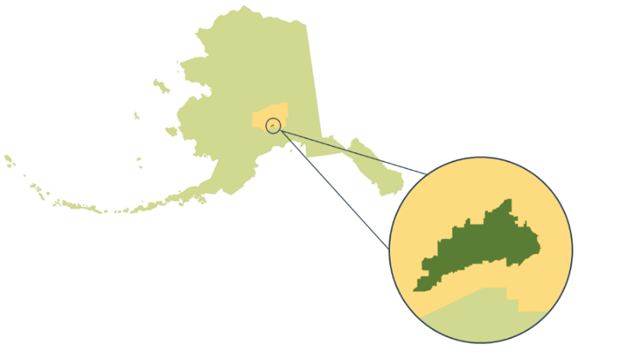
The process of developing MVP began in 2020 in anticipation of the UZA designation with the formation of a Pre-MPO Steering Committee and Pre-MPO Policy Board. These two bodies worked with the MSB Planning Department staff to define the Metropolitan Planning Area (MPA), or the boundary within which the MPO operates. Federal law requires that the MPA must include, at a minimum, the entire UZA and the contiguous area expected to become urbanized within the next 20 years. To meet this requirement, the Pre-MPO Policy Board created a Boundary Development Strategy. This strategy, along with census data and forecasts from the Alaska Department of Labor, was used to define the MPA. The final approved MPA, shown in Figures 1 and 2 includes Palmer, Wasilla, and portions of the Fishhook and Knik-Fairview areas.
Figure 1. Location of MVP Within Alaska.
MVP has a Policy Board, Technical Committee, Executive Director, and staff. The Policy Board is the decision-making body and comprises representatives of local governmental agencies, including the MSB, cities of Palmer and Wasilla, Knik Tribe, Chickaloon Native Village, and the Alaska Department of Transportation & Public Facilities (DOT&PF). The Policy Board is advised by the Technical Committee, which comprises representatives of local governmental agencies and are advocates of transit, active transportation, and the trucking industry. The Executive Director and MVP staff are responsible for the day-to-day operations of the MPO.
MVP is one of three MPOs in Alaska; the other two MPOs are located in Anchorage and Fairbanks. Each MPO receives federal funding from the Federal Highway Administration (FHWA) and Federal Transit Administration (FTA) through the DOT&PF, which follows a formula to divide those funds between the three MPOs. Each MPO has the authority to determine transportation priorities and program federal funding for projects within its MPA. In addition to our Technical Committee, Policy Board, state and federal agencies, and other MPOs, MVP works with our community to incorporate local knowledge and experience in our planning efforts.

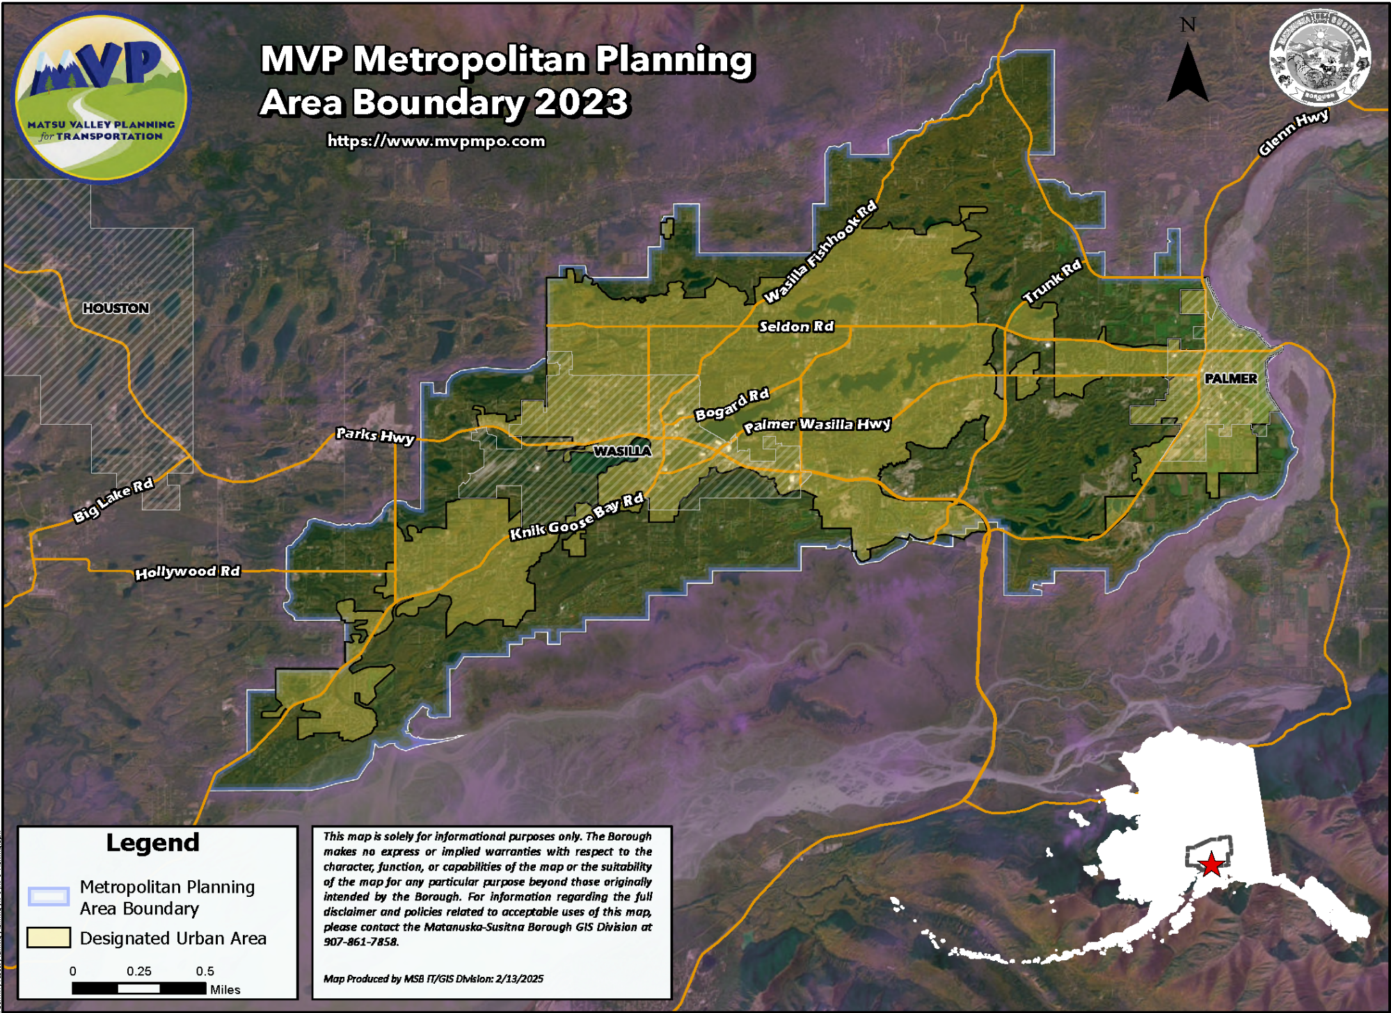
Figure 2 . MVP Metropolitan Planning Area Boundary.

What does MVP do?
MVP is responsible for carrying out a range of essential functions that support effective, inclusive, and performance-driven regional transportation planning. These core functions include:
1. Establish and manage a fair and cooperative setting for effective regional decision-making.
2. Prepare and maintain the following four federally required work products:
- Unified Planning Work Program (UPWP): A document that outlines the annual budget and planning activities to be conducted by MVP.
- Metropolitan Transportation Plan (MTP): A long-range plan that establishes a transportation vision and goals for the region, details the existing multimodal transportation system and future conditions, identifies needs and opportunities for the transportation system, and creates a project list that guides transportation investments into the future (a minimum of 20 years). This document is updated every 5 years and has a 30-day public comment period before adoption. All modes of transportation, including transit, bicycle and pedestrian facilities, freight, and roadways, are addressed in the MTP.
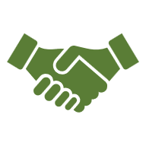
- Transportation Improvement Program (TIP): The short-term project list, which includes federally funded projects and regionally significant projects that are consistent with the MTP, regardless of funding sources. This document is updated every year and has a 30-day public comment period before adoption.
The PPP supports the fulfillment of these core functions by actively engaging the people who live, work, visit, play, and conduct business in the MPA to provide feedback on the goals, priorities, needs, challenges, and opportunities of the transportation system.
- PPP and Title VI Plan: Framework documents that guide public involvement in MVP’s planning efforts. These documents outline MVP’s responsibilities, goals, and strategies for engaging the public on a continual basis. This document is updated as needed and has a 45-day public comment period before adoption.
3. Engage the public by offering all interested persons opportunities to engage in the decision-making functions of the MPO.
4. Ensure compliance with federal and state civil rights and nondiscrimination requirements.
5. Invest in projects and studies that improve access, mobility, safety, and other outcomes for underserved groups while minimizing burdens.
6. Conduct performance-based planning by establishing targets and evaluating the impact of MPO actions.
The development or update of the UPWP, MTP, TIP, and PPP will involve public outreach using the strategies and notification mechanisms defined in this plan, including posting the draft plan on MVP’s website and providing a printed copy of the draft plan at key locations during the public review period. Table 1 describes MVP’s plans and programs.
Table 1. Public Outreach Snapshot for MVP’s Plans and Programs
 | UPWP | MTP | TIP | PPP
Purpose | Operating budget and work plan | Long-range transportation plan (fiscally constrained) | Short-range list of transportation projects (fiscally constrained) | Guidance and minimum requirements for public outreach activities
Update | Every 2 years | Every 5 years | Every year | As needed
Planning Horizon | 2-year outlook | 20–25-year outlook | 4-year outlook | No expiration
Adoption Process | Reviewed by Technical Committee; approved by Policy Board
Public Review Period for Plan Updates | 30 days | 30 days | 30 days | 45 days
Notification of Review Period | Advertisement in the Frontiersman  Announcement on MVP website and the websites of the Policy Board and Technical Committee member organizations  Notification through the Alaska Online Public Notice system and MVP email list  Posts to social media accounts
Required Outreach/Feedback Tools
Online Survey | No | Yes | No | No
Comment Form | Yes | Yes | Yes | Yes
Public Meetings or Workshops | Yes | Yes | Yes | Yes

Because MVP plan documents are living, dynamic documents, they may need to be adjusted between full-plan updates. Federal funding changes, transitions in project timelines, and emerging community needs can all impact the planning documents and require updates. Depending on the type, size, and scope, the edit may require an administrative modification or a full amendment to the document.
The Policy Board defines the procedures for administrative modifications and amendments for MVP plan documents in accordance with federal guidance and requirements.
An administrative modification is a minor revision to a plan or program, such as a minor change to the costs, funding source, or initiation dates of a task, project, or project phase. Administrative modifications do not require a public review or comment period, although the public may provide comments at the Policy Board meeting where the modification is being considered. Administrative modifications require the approval of the Policy Board. The FHWA and FTA must also be notified of administrative modifications as quickly as possible.
An amendment is a major revision to a plan or program, such as adding or deleting a project or a substantial change to the costs, initiation dates, design, or scope of a task, project, or phase of a project. Amendments require a 30-day public review and comment period. Amendments require the concurrence of the Policy Board, DOT&PF, FHWA, and FTA.
Both administrative modifications and amendments to the MTP and TIP require a redemonstration of fiscal constraint. The PPP will not be subject to amendments; any major changes to the plan will be considered a plan update and will be subject to the entire 45-day public comment process.
Table 2 provides a summary of the criteria for administrative modifications and amendments.

Table 2. Requirements for Administrative Modifications and Amendments
Plan or Program | Administrative  Modification | Amendment
UPWP | - Change to the cost of a task when the approved task budget does not exceed 20% of the total program budget OR when the change is less than $35,000. | - Addition or deletion of a task.  - Change to the cost of a task when the approved task budget is greater than or equal to 20% of the total program budget OR when the change is greater than or equal to $35,000.
MTP | - Change to the cost of a project or phase of a project that is less than 20% of the total project cost. | - Addition or deletion of a project.  - Change to the cost of a project or phase of a project that is equal to or greater than 20% of the total project cost.
TIP | - Change to the cost of a project or phase of a project that is less than 20% of the total project cost. | - Addition or deletion of a project.  - Change to the cost of a project or phase of a project that is equal to or greater than 20% of the total project cost.
PPP | - Minor corrections, such as fixing typos or other grammatical errors. | - N/A—major changes will be made through a full-plan update.

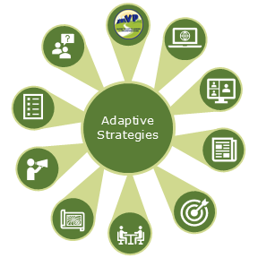
How can people participate?
MVP is always seeking input from the community. Our “everyday engagement tools” are the strategies we use for normal operations to make sure the community stays informed and involved. When MVP is developing a plan and needs more in-depth participation, we use our “comprehensive engagement tools.” The following sections explain who MVP engages and the tools we use to engage them.

Community Partnerships
The work of MVP requires input from many stakeholder groups and individuals to ensure a 3C process. These community partners include:
- Government agencies, including Tribal governments
- Transit operators and transportation companies
- Businesses that ship goods and provide transportation services
- People who use public transit, walk, or bike
- Individuals with disabilities and accessibility needs
- Community organizations and interested residents
The way MVP interacts with stakeholders is different at the federal, state, and local level, but we will strive to maintain effective partnerships with all entities.

Federal Coordination
The FHWA and FTA oversee MVP’s work and ensure that federal standards are met. We also coordinate with military installations and federal land management agencies when their facilities are affected by regional transportation planning.

State Collaboration
The DOT&PF and environmental agencies provide technical expertise and regulatory guidance to support regional planning efforts.

Local Connection
Cities, the borough, universities and colleges, Tribal governments, advocacy groups, and the general public are all essential partners in identifying transportation needs and setting community priorities.

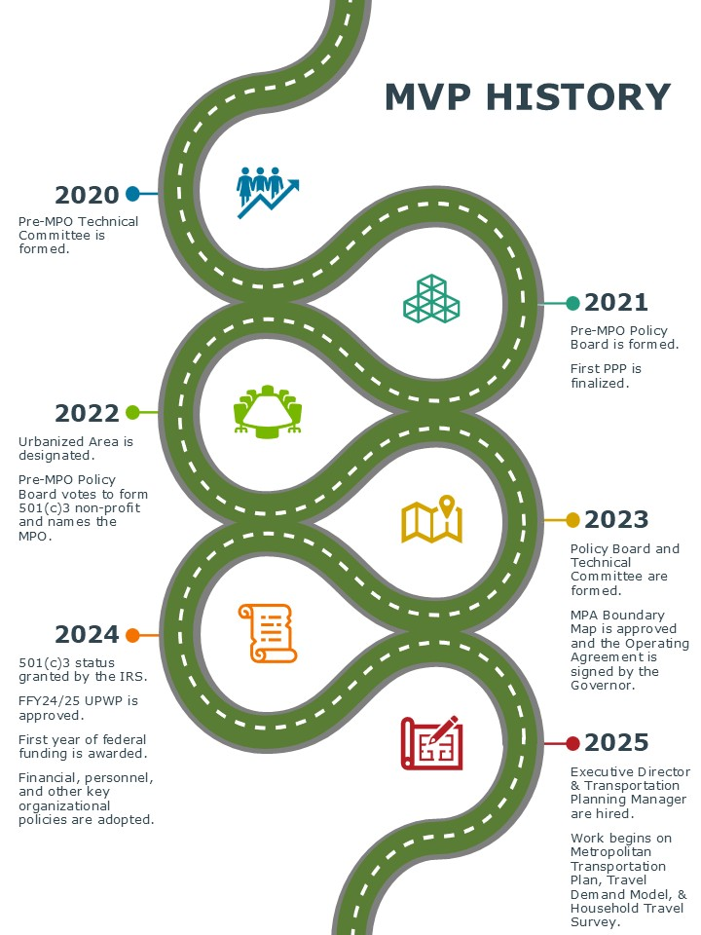

Everyday Engagement Tools
These tools and strategies are applied consistently for routine meetings and ongoing MVP operations. MVP’s everyday engagement tools are outlined below.

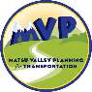
Visual Identity and Recognition
MVP will build and maintain recognizable branding across all materials to strengthen community awareness of its role in regional transportation planning. Branding guidelines will be followed to ensure consistency across communications. This cohesive approach will help the community and stakeholders better understand the function of the newly established MPO.


Digital Presence
- Regularly update MVP website (www.MVPMPO.com) with meeting materials, project updates, participation opportunities, and notices for meetings and proposed administrative changes.
- Include comment forms and surveys on the site as needed.
- Use social media to share transportation updates and meeting announcements, including recurring events, to keep the community informed.
- Post meeting notices on agency websites and community event calendars.
- Manage content updates and create social media accounts to support outreach.

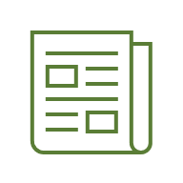
Traditional Media
- Advertise meetings in local newspapers with complete access details.
- Run additional ads on local radio and TV stations as needed.
- Distribute digital and printed calendar cards with annual meeting schedules at popular community locations.
- Create a public event and comment period schedule to support timely outreach.
- Coordinate meeting promotions and deadlines across relevant platforms.


Information Design
- Use professionally designed visuals (e.g., maps, charts, one-pagers, and flyers) to explain technical transportation concepts clearly.
- Maintain a consistent style and quality across all materials to ensure they are accessible and easy to understand at events and open houses.


Community Connection
- Participate in local events with information booths and displays to share updates and engage the community.
- Email stakeholders, partners, and interested residents and build a maintained email list to support ongoing outreach efforts.
- Share updates through the MSB’s Planner Platform e-newsletter until MVP’s newsletter is fully launched.
- Develop a photo library of local transportation infrastructure to enhance social media and public communications.



In-Person Access and Support
- Ensure materials and outreach efforts are accessible to individuals without digital access.
- Provide in-person support when needed to facilitate participation.
- Use visible signage, such as A-frame signs, in high-traffic areas to promote major events.
- Identify key events throughout the planning process to boost accessibility and public awareness through alternative communication methods.

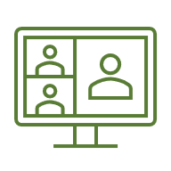
Open Meeting Framework
- The Policy Board and Technical Committee hold monthly meetings, with additional meetings scheduled as needed.
- Except for Executive Sessions, these meetings are open to the public, announced in advance through multiple channels, and offer in-person and virtual access.
- Partner agency meetings will be attended when regional transportation topics are discussed to stay informed and engaged. The protocol for meeting notices is provided in Table 3.
Table 3. Meeting Notice Protocol
Meeting Type | Public Notice Activities
Regular Policy Board or Technical Committee Meetings | - Meeting packet with agenda and materials posted to MVP website at least 5 calendar days before the scheduled meeting.  - Notice of meeting published in the Frontiersman at least 7 days before the scheduled meeting.  - Notice of meeting posted on the State of Alaska Online Public Notice system at least 5 calendar days before the scheduled meeting.
Special Policy Board or Technical Committee Meetings | - Meeting packet with agenda and materials posted to MVP website at least 5 calendar days before the scheduled meeting.  - Notice of meeting published in the Frontiersman at least 7 calendar days before the scheduled meeting.  - Notice of meeting posted on the State of Alaska Online Public Notice system at least 5 calendar days before the scheduled meeting.
Plan-Specific Meeting/Subcommittee Meeting | - Meeting advertised for at least 30 calendar days before the scheduled meeting.

Comprehensive Engagement Tools

Comprehensive engagement tools and strategies will be used in addition to the everyday tools to ensure more comprehensive community input for major planning efforts, significant projects, and other key initiatives.
If the final draft of a plan differs substantially from the initial public review draft, an additional public review period will be held.

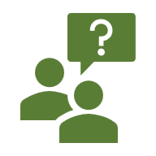
Public Review and Comments
- Hold public review periods for all plan updates and amendments, with draft documents posted on the MVP website and a virtual public comment form available.
- Make draft plans available for in-person viewing and commenting at the MVP office during business hours and at the library during evenings and weekends.
- Post administrative modifications to the MVP website, with public comment opportunities during Policy Board meetings.
- Document all comments received during public review periods and prepare a summary explaining how they were addressed or integrated into the final plan.
- Post all public comments and response summaries to the MVP website.
- If substantial revisions are made after a public review period, hold an additional 30-day public review period for further stakeholder input. The protocol for the plan review period is provided in Table 4.
Table 4. Plan Review Period Notice Protocol
Plan | Draft | Amendment | Administrative Modification
UPWP | 30-day public review and comment period | 30-day public review and comment period | Change posted to website, opportunity to comment at Policy Board meeting
MTP | Public meeting and 30-day public review and comment period | 30-day public review and comment period
TIP | 30-day public review and comment period | 30-day public review and comment period
PPP | 45-day public review and comment period | N/A

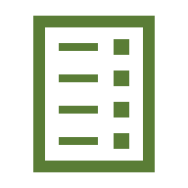
Detailed Communication Plans
- Develop specific, detailed communication plans for activities that require additional public involvement.
- Outline methods and timing for public engagement, including event calendars, comment periods, and surveys.
- Submit communication plans to the Policy Board for approval to guide outreach and ensure transparency and consistency.


Expanded Digital Presence
- Host dedicated pages on the MVP website for key initiatives, serving as central hubs for comment forms, calendars, draft documents, maps, and other materials.
- Include tools such as Geographic Information Systems (GIS) StoryMaps and visual timelines to improve public understanding and engagement.
- Increase social media activity during key outreach periods (e.g., public comment windows or major project milestones).
- Use strategies such as boosted posts, countdowns, and alignment with national events (e.g., Ride to Work Day, Motorcycle Safety Month, and National Stop on Red Week) to expand visibility and participation.

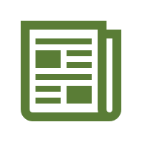
Broader Media Strategy
- Purchase digital and print ads for activities requiring broad public engagement in addition to regular meeting ads in local newspapers.
- Use outreach methods, such as radio interviews and paid airtime, and secure feature coverage in newspapers and local TV news to explain complex planning topics.
- Create short educational videos or live segments to explain planning processes and project details to help increase public understanding and engagement.


Targeted Feedback Collection
- Use interactive tools such as comment maps and surveys (digital and physical) to collect public input on specific plans and projects.
- Share tools through project-specific contact lists to encourage participation and keep stakeholders informed.


Direct Community Outreach
- Host open houses and informal public input sessions at key points in plan and project development.
- Promote events and updates through targeted mailings to affected neighborhoods or stakeholder groups, posters along established flyer routes, and email distribution lists.
- Provide printed copies of draft plans and review documents at libraries and other community hubs for public access.
- Use community bulletin boards and distribute materials at key times to support awareness and participation.

Enhanced Accessibility
- Ensure that all individuals can participate in public involvement opportunities, regardless of communication preferences or abilities.
- Provide materials in digital, print, and large-print formats.
- Offer translation and interpretation services upon request.
- Include accessible and translated content in online resources to support inclusive engagement.

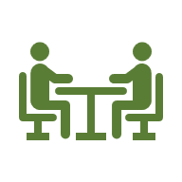
Specialized Engagement
- Convene stakeholder groups and steering committees for project-specific workshops as needed.
- Give presentations to civic organizations, community groups, and educational institutions, and participate in local events and festivals to increase community awareness and interaction.
- Host signature events, such as an annual transportation forum, to share educational materials and gather public input.
- Conduct outreach to Community Councils, Tribal governments, local municipalities, and broader groups (e.g., school districts, youth organizations, health and human service providers, and higher education institutions) to ensure diverse perspectives are represented.

Why is public participation required?
MVP receives funding from the federal government, which means we must follow federal laws governing the use of the funds and the rights of the public. This section will describe the key points of the regulations that MVP must follow.
Relevant laws include:
- The Infrastructure Investment and Jobs Act, the current federal transportation funding law.
- The Fixing America’s Surface Transportation Act, previous transportation legislation that established many current requirements.
- The United States Code (U.S.C.) and the Code of Federal Regulations (CFR), especially 23 U.S.C. §134, 23 CFR Part 450, 49 U.S.C. §5303, and 49 CFR Part 613, which provide specific rules governing how transportation planning must be conducted.
- Title VI of the Civil Rights Act of 1964, which forbids entities that receive federal funds from discrimination on the basis of race, color, or national origin.
According to these laws, MVP must maintain a PPP that creates clear, open pathways for community members, organizations, and agencies to participate meaningfully in transportation decision-making. MVP’s planning and decision making processes must adhere to the 3Cs. MVP incorporates the 3Cs into its transportation planning process by acting as a liaison between federal, state, and local government agencies, communities, and residents. MVP’s public participation process is designed to support broad engagement by residents of the MPA and, in some cases, residents of the MSB, by using multiple outreach, engagement, and public participation strategies.
Federal regulations identify the minimum list of interested parties that must be provided reasonable opportunities to be involved with the metropolitan transportation planning process. MVP will actively engage the parties identified in the federal regulations and any other locally relevant individuals, groups, or agencies. In the MatSu Valley, these parties will include but are not be limited to:
- Alaska Railroad Corporation  - Chickaloon Native Village  - Cities  - Community Councils  - Knik Tribe  - MSB  - MSB School District  - Port MacKenzie Officials | - Residents of the MPA  - Residents of the region beyond the MPA, as appropriate  - Local Road Service Area Advisory Board  - Transit Service Providers  - Bike and Pedestrian Advocates
This list is subject to change as other interested parties are identified through the planning and outreach processes.
In addition to including the representatives of the Knik Tribe and Chickaloon Native Village on the Policy Board, MVP will consult directly with Tribal governments.
MVP will also consult directly with any local, state, and federal agencies that may be impacted by the actions and projects of MVP. To the extent practicable, MVP will document roles, responsibilities, and key decision points for consultation with other governments and agencies, as required by federal regulations.
By engaging early and often with community planning partners, MVP can build strong working relationships while providing residents with the opportunity to provide valuable input at every stage of planning efforts. Our efforts are always aimed towards transparency and inclusion; this is not only legally required but also improves the planning outcomes. The following sections provide more information about how MVP promotes access and accountability in every step of the planning and decision making process.

Equity and Nondiscrimination
As a direct recipient of federal funding, MVP must follow federal nondiscrimination requirements, including those outlined in Title VI of the Civil Rights Act of 1964. MVP’s Title VI Plan, available on the MVP website, outlines how MVP will ensure that people of all races, income levels, ages, abilities, and genders have equal input in, and equally benefit from, the planning and project delivery processes of MVP.

Removing Barriers to Participation
All stakeholders in the MPA and surrounding area have a right to participate fully in the transportation planning process. MVP recognizes that certain groups, such as individuals with limited English proficiency, minorities, and lower-income residents, have historically been left out of decision-making processes or face more significant barriers to participation than others. These groups are considered “underrepresented” in the planning process and are often underserved by infrastructure and services. MVP strives to engage these individuals and neighborhoods to support a fair planning process. Strategies to do so may include the following:

- Attending community events in the areas and neighborhoods where underrepresented residents live, work, and play.
The MVP Title VI Plan ensures that all races, income levels, ages, abilities, and genders have equal input in, and equally benefit from, the planning and project delivery processes of MVP.
- Holding multiple MVP-organized events for a single outreach effort to ensure that events are held in locations and at times convenient for the broad range of schedules, places of work and residence, and modes of transportation.
- Partnering with local organizations that work with underrepresented communities to advertise meetings, comment periods, and planning efforts.

Requests for Special Accommodations and Complaints Procedure
The complaints procedure for civil rights violations or discrimination is included in the Title VI Plan and on the website. Requests for accommodations, such as printed materials, translated materials, an interpreter, or Americans with Disabilities Act (ADA) accommodations, may be sent to the MVP Executive Director.

Monthly Open Meetings
MVP hosts two monthly meetings—the Technical Committee and the Policy Board—that offer valuable opportunities for community members to contribute their ideas, needs, and concerns to any planning effort. The Technical Committee serves as the working group of agency staff and transportation advocates who develop recommendations based on technical analysis and community input. These recommendations are then reviewed and acted upon by the Policy Board, a decision-making body composed of elected officials and agency representatives. Attending these meetings allows residents to share ideas, voice concerns, and influence decisions that shape local transportation priorities. The following guidelines will apply to the public process at all MVP Policy Board and committee meetings:
- An optional sign-in sheet will be available for in-person and virtual attendees. The information collected through the sign-in sheet will be used to track meeting attendance and add interested parties to the MVP mailing list.
- Every Policy Board and Technical Committee meeting will have a “Voices of the Visitors” item on the agenda to allow public comment on any topic not listed as an action item on the agenda. The Chair may specify a time limit for public testimony at the beginning of each meeting.
- All action items will include an opportunity for public comment during the meeting.
- Comments may be submitted in writing before the meeting and will be read into the record at the appropriate time in the agenda.
- Items on a meeting agenda may be voted on, or an action item may be deferred, tabled, or referred back to a committee for further consideration at the Board’s discretion.
- Past meeting materials, including agendas, minutes, packets, and approved planning documents, will be posted on the MVP website (www.MVPMPO.com).

Ongoing Online Access
MVP uses online participation tools, including a website. To support accessibility, the website can be automatically translated into several languages commonly used in the MPA and surrounding region, and the font size can be adjusted for greater readability. MVP may also provide closed captioning upon request for virtual meetings and video recordings via the virtual meeting platform and/or YouTube.
Online engagement strategies increase the accessibility and reach of MVP’s engagement activities but are unsuitable for all stakeholders. To ensure the greatest degree of engagement, MVP does not limit its outreach activities to online methods, which promotes engagement by individuals who do not have access to the internet, are not comfortable using technology, or otherwise prefer nondigital methods of interaction. The following section dives into the comprehensive outreach methods MVP uses to interact with the public.

How does MVP measure success?
As part of the 3C transportation planning process, MVP measures public engagement to ensure that outreach efforts are inclusive, effective, and responsive to community needs. To understand if MVP is reaching a broad audience, we will track data for measures of success like those outlined in Table 5. MVP also encourages members of the public to provide direct feedback on the public participation process to help MVP improve.
During each update to the PPP, MVP will review outreach efforts to date using these measures and adjust strategies as needed.
Table 5. Example Measures by Type of Activity
In-Person
- Number of presentations given
- Number of tabling events
- Number of visitors at tabling events
Analog
- Number of survey responses
- Phone calls received
- Letters received
Digital
- Number of website comment form submissions
- Number of emails received
- Number of interactive map comments
- Number of survey responses

Conclusion
MVP is deeply committed to conducting a public participation process that engages the diverse community of the MatSu Valley early and consistently throughout all planning processes. MVP will periodically update and reevaluate this PPP to ensure that it remains consistent with trends and needs of the communities within and around the MPA. The PPP will be reevaluated and may be updated before each MTP update and may be updated through amendments and administrative modifications at any time, as outlined in this document.

Abbreviations and Definitions
3Cs – Continuous, Cooperative, and Comprehensive transportation planning process identified in 23 CFR § 450.306(b).
ADA – Americans with Disabilities Act is a 1990 civil rights law that prohibits discrimination against individuals with disabilities in all areas of public life, including jobs, schools, transportation, and all public and private places open to the general public.
Administrative modification is a minor revision to Metropolitan Planning Organization documents, including a Metropolitan Transportation Plan, Public Participation Plan, Unified Planning Work Program, Transportation Improvement Program, or Statewide Transportation Improvement Program that includes minor changes to project/project phase costs, minor changes to funding sources of previously included projects, and minor changes to project/project phase initiation dates. An administrative modification is a revision that does not require public review and comment, a redemonstration of fiscal constraint, or a conformity determination (in nonattainment and maintenance areas).
Amendment is a revision to Metropolitan Planning Organization documents, including a Metropolitan Transportation Plan, Public Participation Plan, Unified Planning Work Program, Transportation Improvement Program, or Statewide Transportation Improvement Program that includes the addition or deletion of a project or a major change in project cost, project/project phase initiation dates, or a major change in design concept or design scope (e.g., changing project termini or the number of through-traffic lanes or changing the number of stations in the case of fixed guideway transit projects). Changes to projects that are included only for illustrative purposes do not require an amendment. An amendment is a revision that requires public review and comment and a redemonstration of fiscal constraint.
CFR – Code of Federal Regulations is the codification of the general and permanent regulations published in the Federal Register by the executive departments and agencies of the United States federal government.
DOT&PF – Alaska Department of Transportation and Public Facilities is a department within the government of Alaska focused on the state’s transportation and public infrastructure.
FHWA – Federal Highway Administration is a division of the United States Department of Transportation specializing in highway transportation. The agency’s major activities are grouped into two programs: the Federal-Aid Highway Program and the Federal Lands Highway Program.

FTA – Federal Transit Administration is division of the United States Department of Transportation that provides financial and technical assistance to local public transportation systems. The FTA is one of ten modal administrations within the Department of Transportation.
GIS – Geographic Information Systems are computerized mapping programs that aid in visualizing existing conditions and proposed transportation planning interventions.
MatSu Valley – The Matanuska-Susitna Valley, the region within which the Matanuska-Susitna Borough resides.
MPA – Metropolitan Planning Area is the geographic area determined by agreement between the Metropolitan Planning Organization for the area and the Governor, in which the metropolitan transportation planning process is carried out. The MPA must comprise, at minimum, the “urbanized area” as defined by the U.S. Census Bureau and the contiguous area expected to become urbanized within the next 20 years.
MPO – Metropolitan Planning Organization is the policy board of an organization created and designated to carry out the metropolitan transportation planning process.
MSB – Matanuska-Susitna Borough is the “county-level” government for the MatSu Valley region.
MTP – Metropolitan Transportation Plan is the official multimodal transportation plan addressing no less than a 20-year planning horizon that the Metropolitan Planning Organization develops, adopts, and updates through the metropolitan transportation planning process.
MVP – MatSu Valley Planning for Transportation is the metropolitan planning organization for the MatSu Valley region.
N/A – Not applicable is used where the data being shown is not relevant.
PPP – Public Participation Plan is the blueprint outlining a Metropolitan Planning Organization’s public participation strategies and activities.
TIP – Transportation Improvement Program is a prioritized listing/program of transportation projects covering 4 years that is developed and formally adopted by a Metropolitan Planning Organization as part of the metropolitan transportation planning process, consistent with the Metropolitan Transportation Plan, and required for projects to be eligible for funding under Title 23 U.S.C. and Title 49 U.S.C. Chapter 53.
Title VI refers to Title VI, 42 U.S.C. § 2000d et seq. of the Civil Rights Act of 1964. It prohibits discrimination on the basis of race, color, and national origin in programs and activities receiving federal financial assistance.
UPWP – Unified Planning Work Program is a statement of work identifying the planning priorities and activities to be carried out within a metropolitan planning area. At a minimum, a UPWP includes a description of the planning work and resulting products, who will perform the work, time frames for completing the work, the cost of the work, and the source(s) of funds.
U.S.C. – United States Code is the official codification of the general and permanent federal statutes of the United States.
UZA – Urbanized Area is a geographic area with a population of 50,000 or more, as designated by the U.S. Census Bureau.

23 CFR § 450.310
Additional criteria, including housing density thresholds, can be found in the Federal Register: Urban Area Criteria for the 2020 Census—Final Criteria
23 CFR § 450.312
23 CFR § 450.306(b)
23 CFR § 450.316(a)
23 CFR § 450.316(e)

